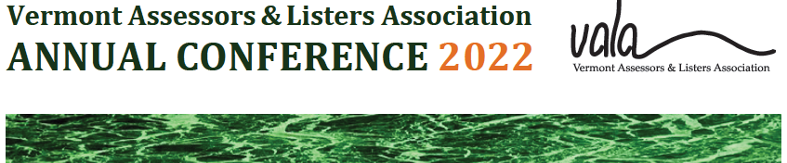

VERMONT ASSOCIATION OF LISTERS AND ASSESSORS
2022 ANNUAL CONFERENCE MINUTES
09/16/22
9:00 A.M. Meeting called to order: By President Lisa Wright
County delegates present: Chittenden, Franklin, Grand Isle, Lamoille, Orange, Orleans, Rutland, Windham, Windsor. Counties not present include Addison, Bennington, Caledonia, and Washington, Essex delegate seats remain vacant.

Secretaries Minutes: with 118 attendees present, J. Fike (Reading) made a motion to accept the secretary’s minutes from the 2021conference. J. Johnson (Cabot) seconded that motion. The motion passed and the minutes were approved.

Presidents Report: Will continue to offer hybrid meetings. It has resulted in an increase in attendance and participation.

Treasurer's Report: Lisa Wright explained the revenue and expenditures of last year. The ending balance was $15,535.37

Auditors Report: P. McNall stated that all is in order. Noted that there is difference between the checkbook ending balance ($54,701.28) and the bank ending balance ($59,520.30) which is due to outstanding checks in the amount of $4,818.75 which balances. P. Hayward asked why the membership income is so elevated compared to the previous year. L .Truchon responded that it is due to the increased out-of-state participation in the IAAO classes that were held. J. Fike (Reading) commented that nonprofits cannot have income and therefore cannot have profit or loss (referring to the “Net Profit/Loss” line on the Year End Report). L. Truchon stated that it should be labeled as “Net Reserve” and it would be adjusted accordingly.
Education Committee: E. Curran reported 5 IAAO courses offered this year: 101, 155, 171, 300 and 452. In the 101 class, there were 23 participants; 10 of them from VT. Online classes do well and will continue to be offered this way.

Membership Committee: E. Curran reported 131 member entities up from last year’s 106. 350 +/- actual members, considering some towns did not list there assessors or listers. New County delegates were chosen.

Slate of Officers: Secretary Stacey Bradley chose to not seek reappointment. Lisa Wright made a motion to appoint Jacob Dorman, M. Teeter (Castleton) seconded the motion. J. Dorman appointed to Secretary. : President Lisa Wright- Phyllis nominated; Jean seconded; Lisa accepted. Vice President Cheryl Tudhope- Stacey nominated; Terri Sabens seconded; Cheryl accepted. Treasurer Lisa Truchon-Pat McNall nominated; Patti King seconded; Lisa accepted.Officers Elected for 2022-2023 President Lisa Wright; Vice President Cheryl Tudhope; Secretary Jacob Dorman; Treasurer Lisa Truchon.

Legislative: Lisa Wright and Cheryl Tudhope reported still need to have someone step up to help fill this need of following the state legislature. Need better support from VLCT. While PVR is involved, in some cases it is not ideal to have them work on behalf of VALA. Still considering hiring someone to fill this need.
Elizabeth Curran commented that there is a need to have lots of varied people with varied skills involved as volunteers in VALA. To which a question was posed by J. Vickery if there was a place to go look at the description of volunteer options and where volunteers were needed.
New Business: No other new business to report at this time.
LOTY: With co-workers and family members present, the 2022 Lister of the Year award was presented to Jean Newall in recognition of her 24 years of service as a lister in Dummerston, VT.

The rest of the day was spent with dialogue with the sponsors and presentations by the keynote speakers John Fike, and John Valente. Sponsors included; AXIOMATIC, CAI, MASCOMA BANK, NEMC, SAFEGROUND ANALYTICS, TYLER TECHNOLOGIES, VCGI, VISION, PVR and NEMRC. The day ended with breakout sessions a final forum and sponsored gift giveaway. Guest Speakers: J. Vickery, C. Miele, T. Sabens, C. Wright, and T. Gildersleeve.

ADJOURNED at 3:45. Respectfully submitted, Jacob Dorman Secretary

